**NAME: FATIMA JAMEEL**

**ARIDNO: 21-ARID-412**

**SECTION: 6 (A)**

**ASSIGNMENT #1**

**Scenario: Different Screen Sizes and Densities**

**1. Create Layouts for Different Screen Sizes**

**Objective**: Provide different layouts for small, normal, large, and xlarge screens to ensure the UI adapts appropriately.

**Define the Layouts**:

* Create different activity_main.xml files for each screen size qualifier.

**Default Layout (res/layout/activity_main.xml)**:

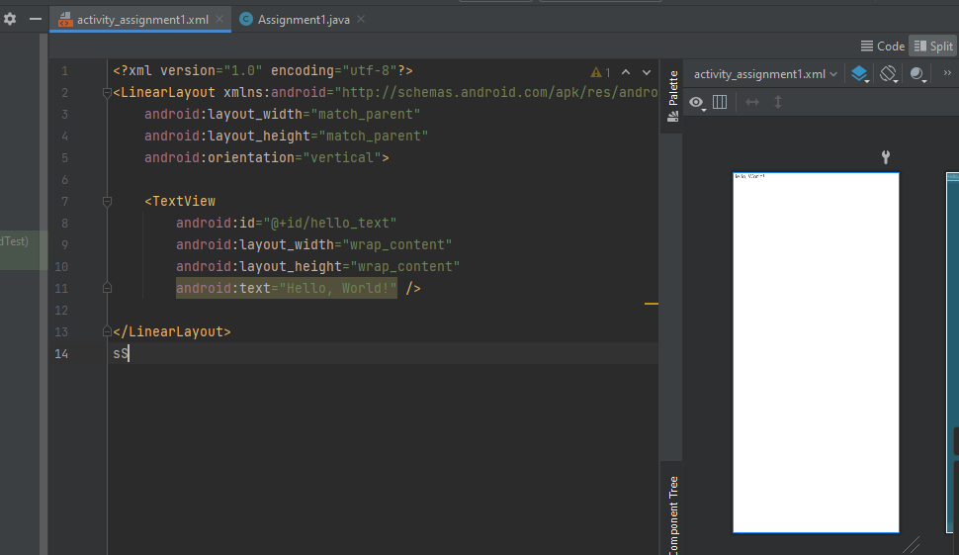

**Small Screen Layout (res/layout-small/activity_main.xml):**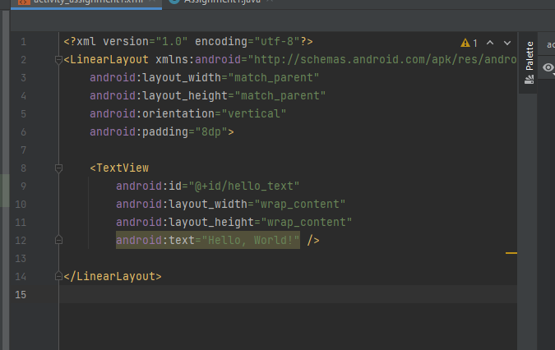

**Large Screen Layout (res/layout-large/activity_main.xml)**: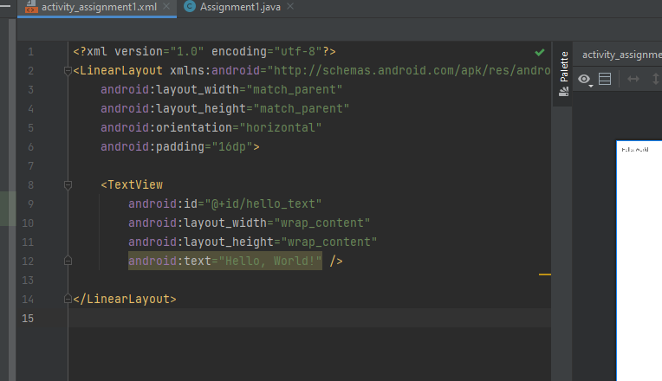

**Xlarge Screen Layout (res/layout-xlarge/activity_main.xml)**:

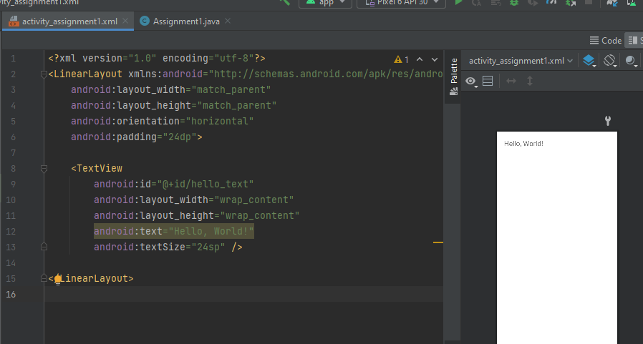

**Dependencies:**

dependencies {

implementation 'androidx.core:core:1.10.1'

implementation 'androidx.appcompat:appcompat:1.6.1'

implementation 'com.google.android.material:material:1.9.0'

implementation 'androidx.constraintlayout:constraintlayout:2.1.4'

testImplementation 'junit:junit:4.13.2'

androidTestImplementation 'androidx.test.ext:junit:1.1.5'

androidTestImplementation 'androidx.test.espresso:espresso-core:3.5.1'

}